Artwork Design Specification:

If you are new to providing Artwork do not get concerned about the information below, if you need further explanation please contact us and we would be happy to walk you through the process.

To ensure we achieve the best reproduction of your design we request artwork (including logos) to be supplied to us in a vector format using:

- Adobe Illustrator
- EPS files
- High Resolution PDF*
- And other graphics (such as photos) supplied as Adobe Photoshop PSD files,

*The format most people would have used before is “PDF”. Whether we can use a PDF will depend on what the artwork was originally designed in. However e-mail your PDF through and we will advise if we can work with it. We also mention high resolution by this we mean the PDF needs to be sent to us with a minimum resolution of 300dpi.

Why do we need a vectored file , the answer is, scalable vector files can be sized to very large or very small sizes without losing or compromising quality, and it also gives us the ability to edit at the same high quality. If the original vector logo is unavailable, then we can recreate it for a fee. Please note that we cannot guarantee complete accuracy with this process however.

Unfortunately artwork sent to us by way of Microsoft products such as word, publisher and power point will not achieve the desired result

Fonts and File Linking

Every computer has a different set of fonts installed on it, so you should never assume that we have the particular font you use, available to us. It is often illegal to deliver font files with your logo, so it is important that you convert all your text to paths, curves or outlines. This step will convert all fonts into a vector shape, and will not allow the text to be edited any further.

Please ensure that all linked files are also included and refrain from embedding files in documents, or if you do, then ensure that there is a separate copy of the file as well. Preferably, if the original graphic was produced in Photoshop with layers, please include that original document as well.

Resolutions

As already alluded to the minimum acceptable resolution is 300dpi for colour, halftone or grayscale images, and at 1200dpi for line art. The files must be saved at least twice the print size required.

Colours

For spot colour printing, we use the Pantone PMS colour matching system. Every computer system shows colours slightly differently whereas when you provide us with a PMS number we can match the colour if not exact, very closely.

Design Outsourcing

If you do not have access to card design then we offer a complete design service at very competitive rates.

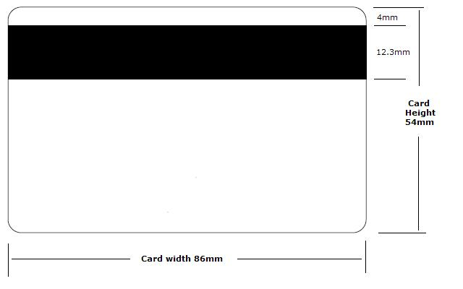
Proof

We will e-mail you a digital proof to be approved before production starts.

